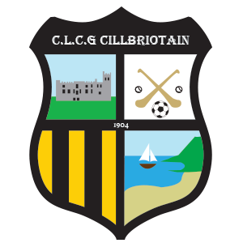
Kilbrittain GAA AGM
3rd December 2021
Nomination Form

Nominations must be returned by email to Club Secretary secretary.kilbrittain.cork@gaa.ie
not later than 5pm on Sunday 14rd November 2021

N.B. The consent of persons being nominated must be obtained in advance

Position | Outgoing |  | Your Nomination 2022
President | Frank O'Brien
Chairperson | Dermot Hayes
Vice Chairperson | Denis Ryan
Secretary | Marion Twohig
Asst. Secretary | Lorna Ryan
Treasurer | Ollie O’Brien
Asst. Treasurer | Eoghan Byrne
PRO | Brian Hickey
Asst. PRO | James Hurley
County Board delegate | Con Healy
County Board delegate | Paddy Ryan
Child Protection Officer | Judy Sexton (not seeking re-election) |  | Vacant
Officer for Irish Language and Culture | Nick O’Donovan
Pitch Officer | Tommy Brenan
Coaching Officer | Kevin Kingston (not seeking re-election) |  | Vacant

Nominated by _______________________________

